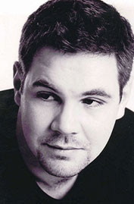
Andrew Haveron

Biography Aug 07

The highest British prize-winner at the prestigious 'Paganini' competition for the last fifty years, Andrew Haveron is one of the UK's most sought after violinists. He was born in London in 1975 and took up the violin aged five. After studying at the Purcell School and London's Royal College of Music with Dr. Felix Andrievsky, Andrew also took prizes at the 'Queen Elisabeth' and Indianapolis competitions.

Since making his concerto debut aged fifteen Andrew has appeared with conductors such as Sir Roger Norrington, Kent Nagano, Stanislaw Skrowachewski, Raymond Leppard, John Lubbock, Jean-Jacques Kanteroff, Darrell Davison and John Wilson, performing a broad range of well known and less familiar repertoire.

In 1999 Andrew was appointed first violinist of the internationally acclaimed Brodsky Quartet. A busy schedule saw the quartet perform and broadcast in their unique style all over the world. Andrew recorded more than fifteen CDs with the quartet, many of which received industry awards such as "Diapason d'or" and "Choc du Monde".

Andrew also enjoys frequent invitations to guest lead major symphony orchestras including the London Symphony, the Royal Philharmonic and the Philharmonia orchestras and in July this year took up his new post as leader of the BBC Symphony Orchestra.

In 2004 Andrew received an honorary Doctorate from the University of Kent for his services to music.

Andrew plays on a violin made for him in 2001 by the American luthier Sam Zygmuntowicz.

